Go to https://www.kentschools.net/ccarman/cp-chemistry/practice-quizzes/compound-naming/
Make sure all the following are checked like this before you start
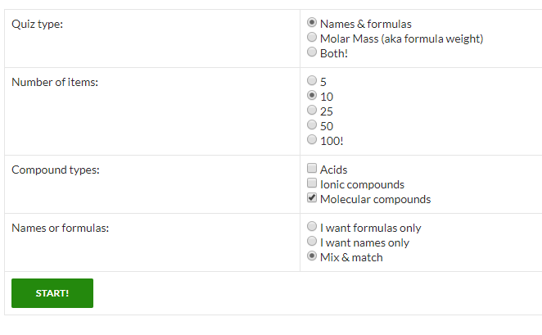
Remember:
1 = mono
2 = di
3 = tri
4 = tetra
5 = penta
6 = hexa
7 = hepta
8 = octa
9 = nona
10 = deca

Then complete this quiz https://www.proprofs.com/quiz-school/story.php?title=simple-word-equations-quiz

Then: play this game http://www.chemicalformula.org/chemistry-games/1st-20-elements-of-the-periodic-table
Then this crossword: http://chemicalformula.org/chemistry-games/crosswords/periodic-table/

